

UET Peshawar
Department Of Computer Science
Lab Task 06-Composition-in-java

Submitted By:
Waqas Khan S/o Azeem Khan CSIT pwr Batch-24
RegNo : 24pwbcs1141

Submitted To:
Sir Syed Adeel Ali Shah Associate Professor CS&IT Peshawar

Task for Students
Problem Statement
Create a program that models a Smartphone using composition. The Smartphone class should have the following components:
- Screen:
  - Attributes: size, resolution, type (e.g., AMOLED, LCD).
  - Methods: display(String content) to show content on the screen.
- Battery:
  - Attributes: capacity (in mAh), percentage.
  - Methods: charge(int amount), use(int amount) to simulate battery usage and charging.
- Processor:
  - Attributes: model, cores, clockSpeed (in GHz).
  - Methods: process(String task) to simulate processing a task.
- Camera:
  - Attributes: resolution (in MP), type (e.g., wide, ultra-wide).
  - Methods: clickPicture().
Guidelines:
- Define each component as a separate class with appropriate attributes and methods.
- Create a Smartphone class that contains these components.
- Write a main program to:
  - Create objects for each component.
  - Combine them to create a Smartphone.
  - Demonstrate the usage of each component.

Expected Outcome
Students will understand:
- How to model real-world objects using composition.
- The benefits of modular code design.
- How to create and use objects within other classes.

Main.java Files

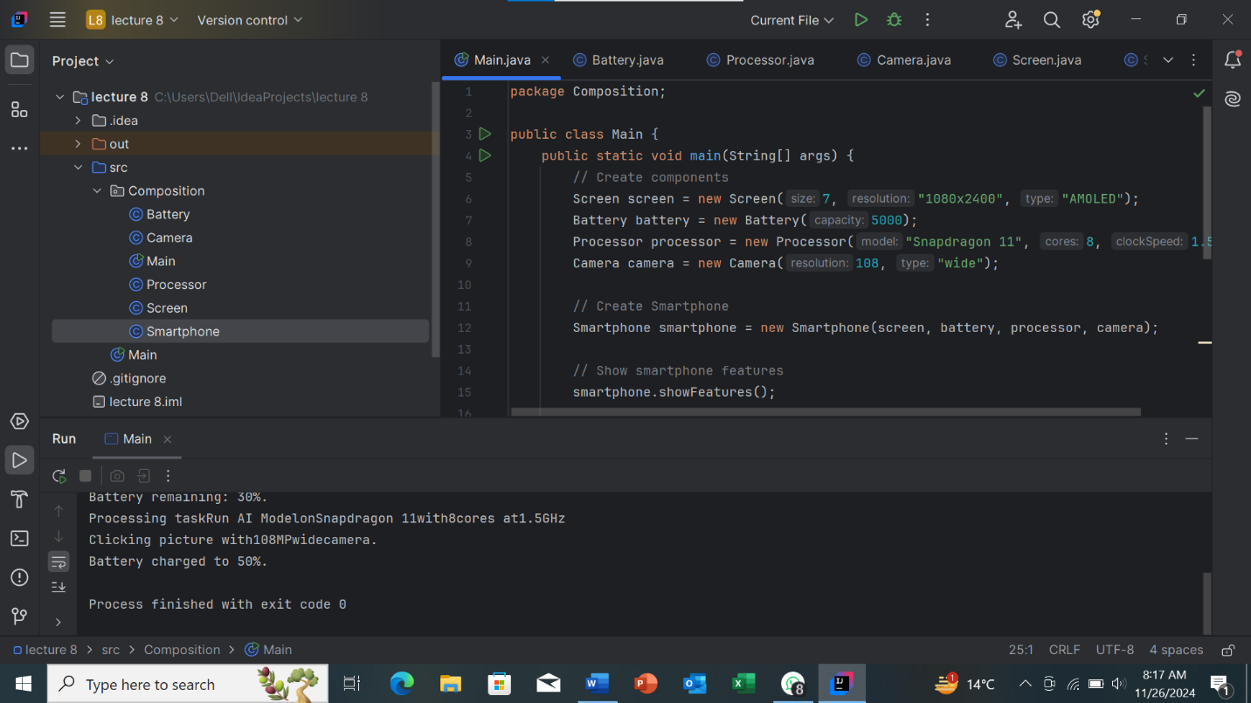

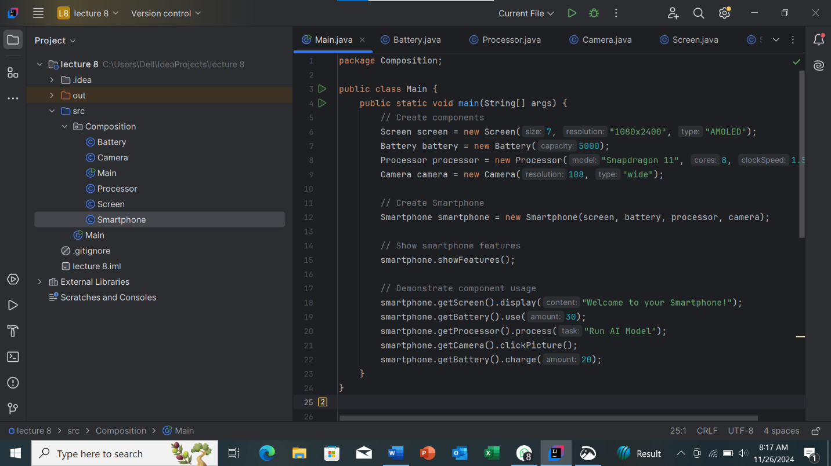

SmartPhone.java Files

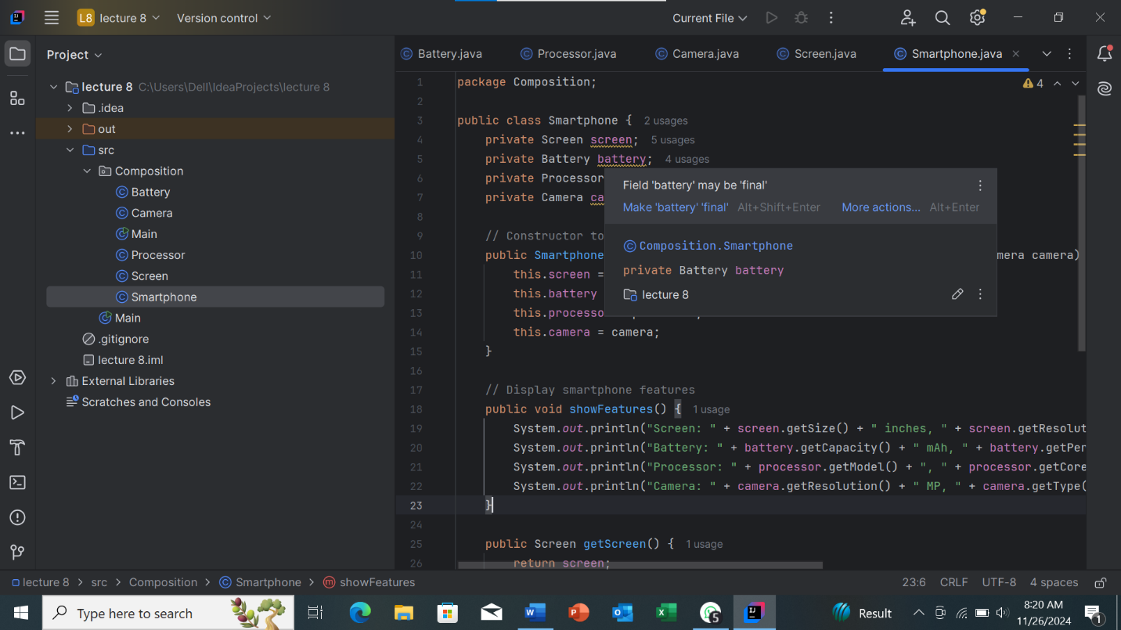

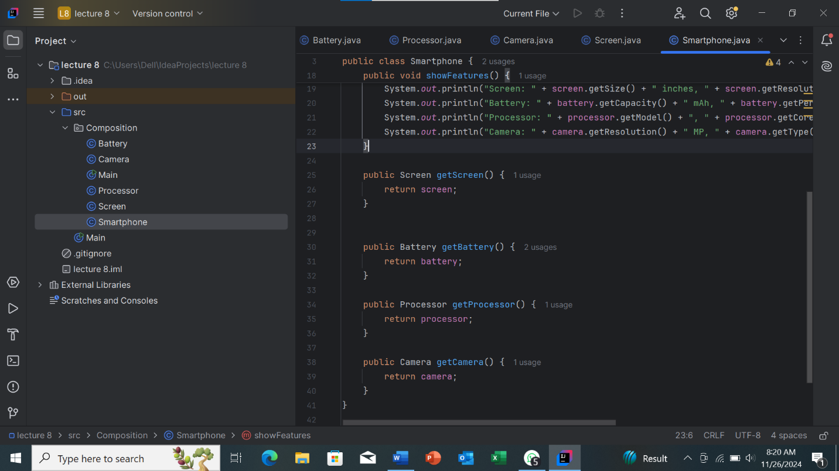

Screen.java Files

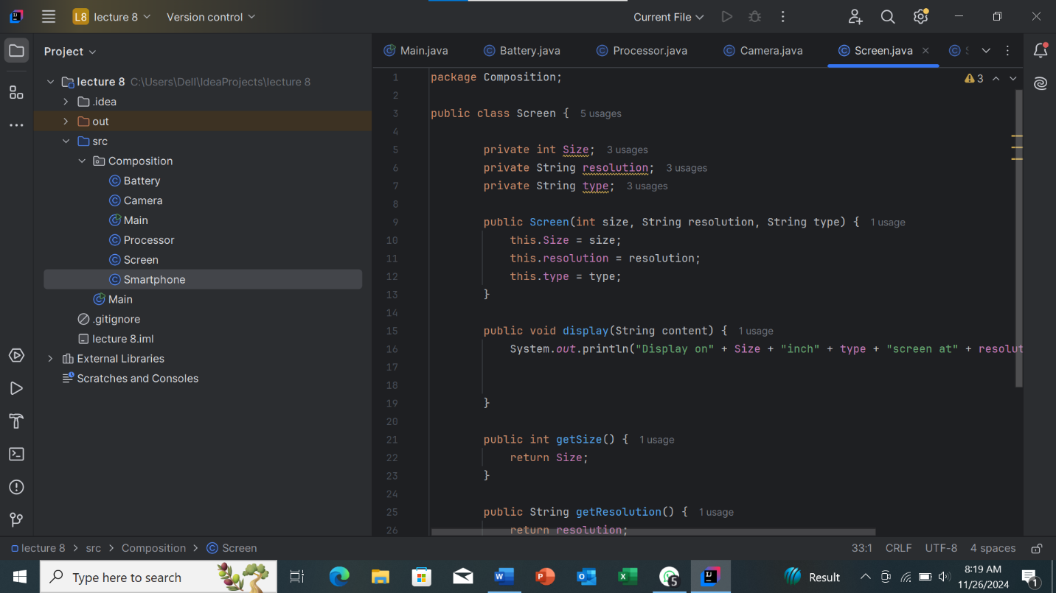

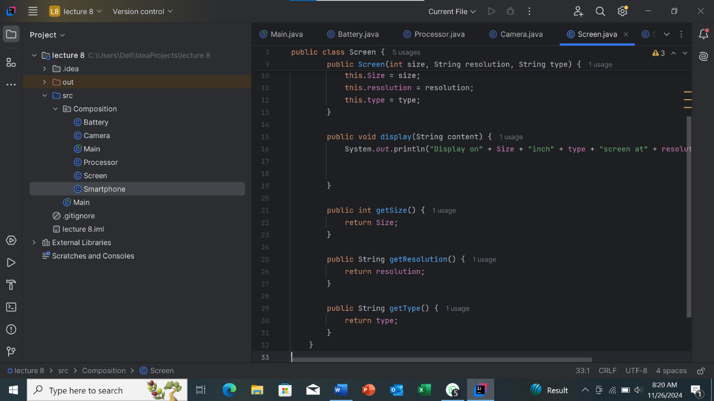

Processor.java Files

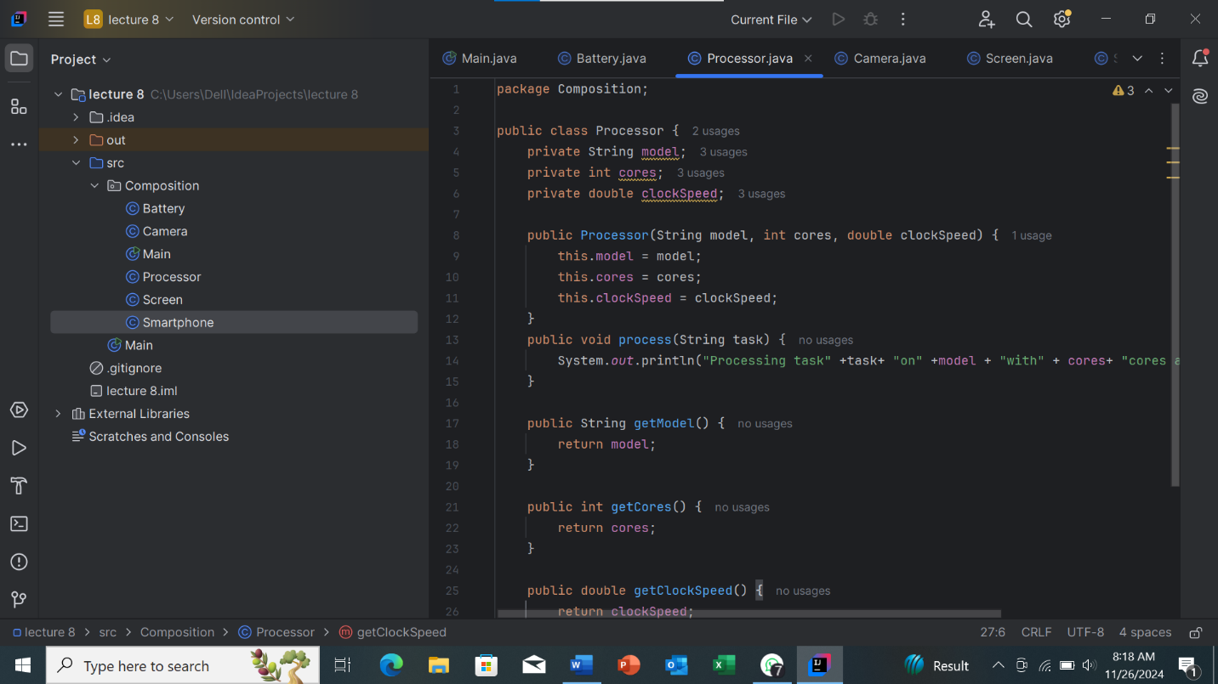

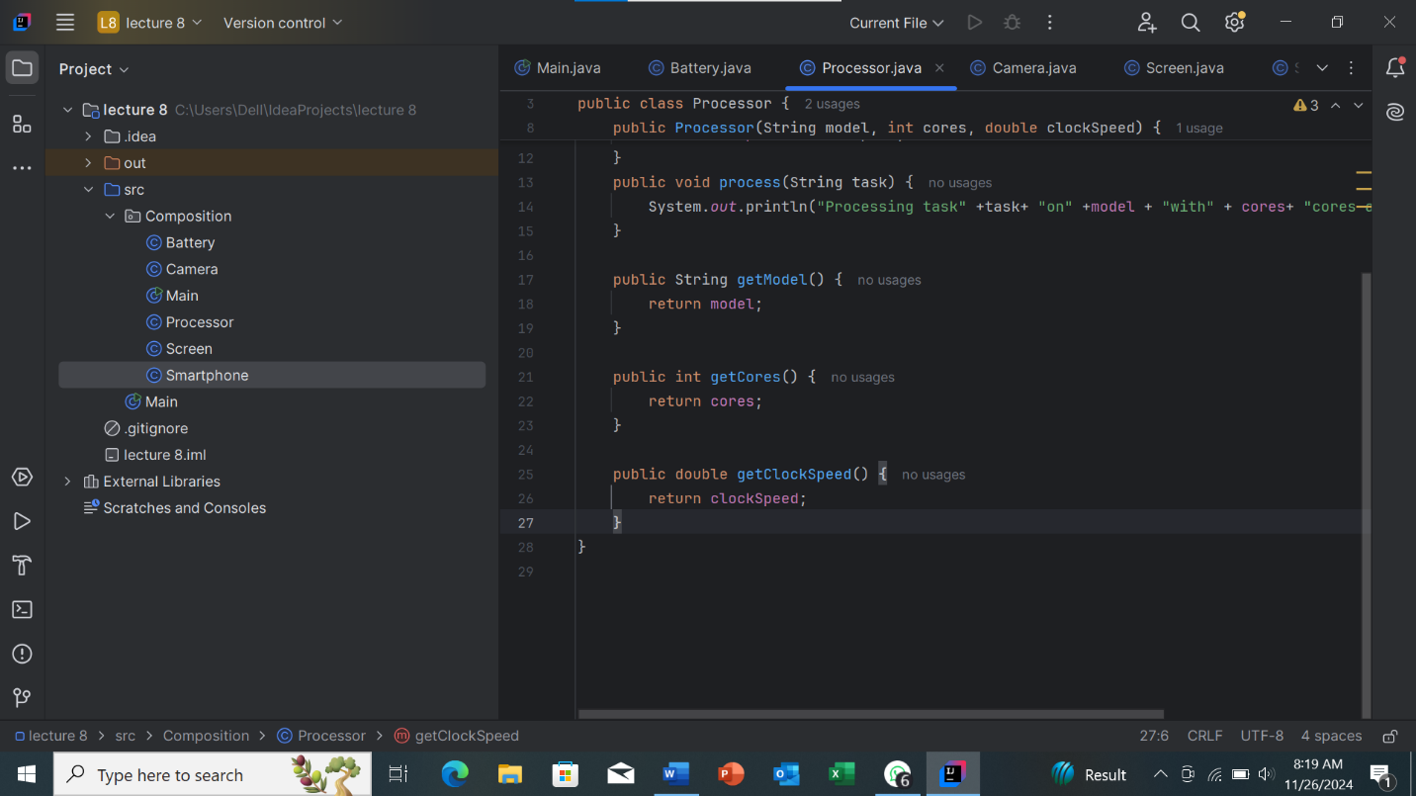

Battery.java Files

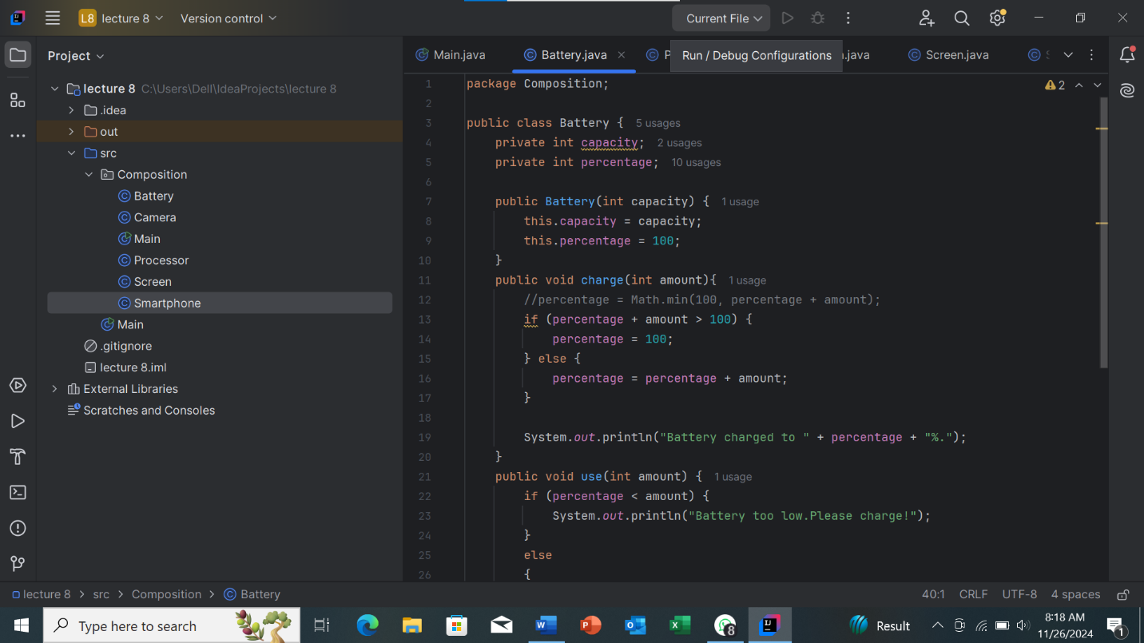

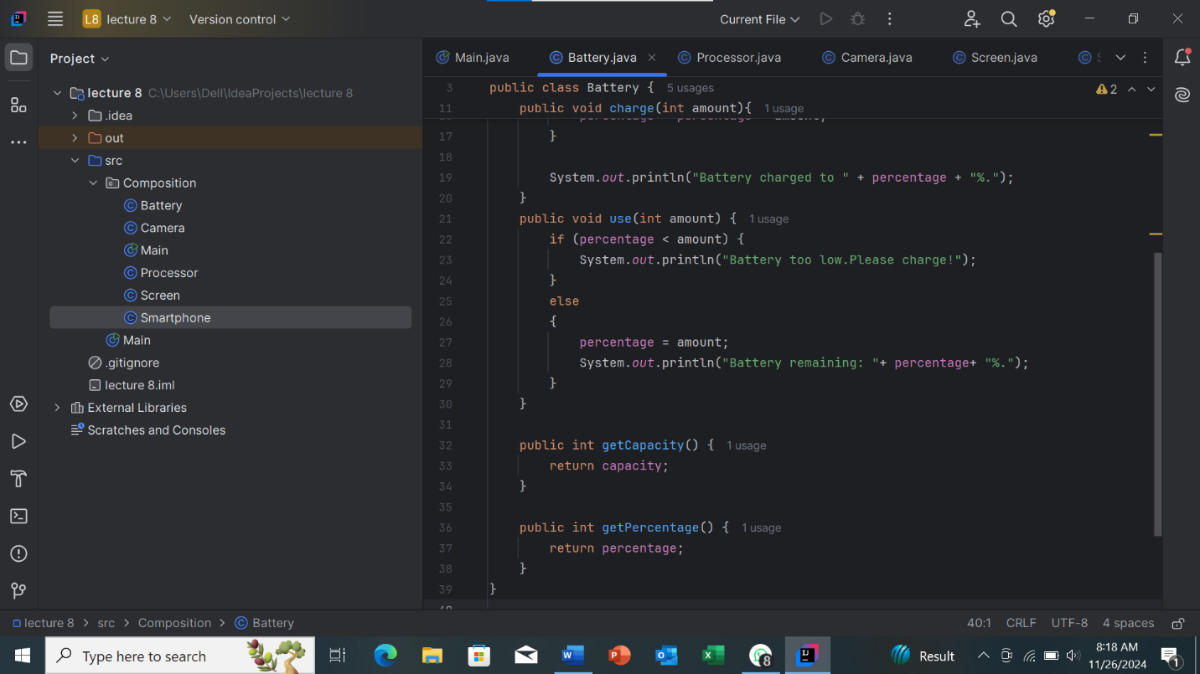

Camra.java Files

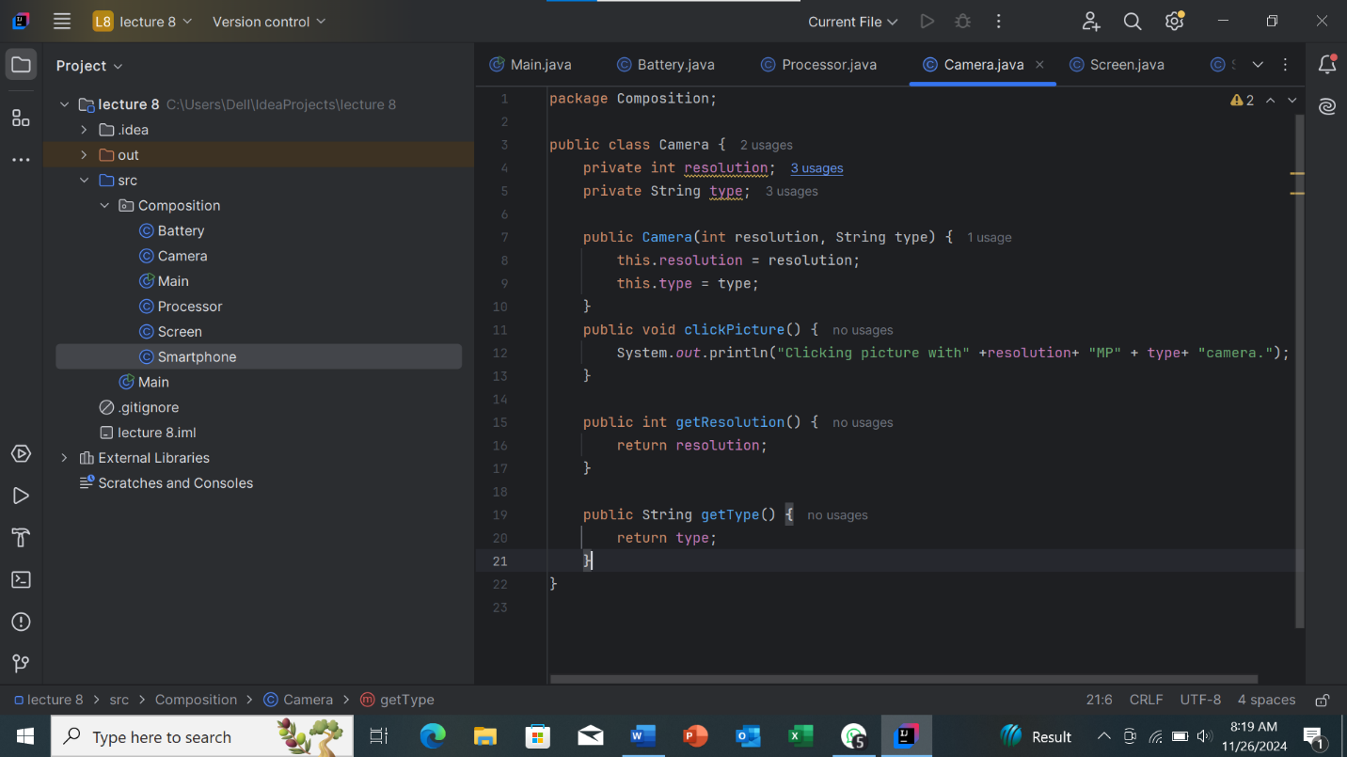

Thank You !..

